

root@cyberster:~$ whoami
> hanzallah — soc_intern
DAY
15–16
Network Intrusion Detection — Suricata
// candidate Hanzallah
// program Cyberster — Cybersecurity Internship (Batch 2)
// tutor Abdullah Zia
[ STATUS: TASKS COMPLETE — READY FOR REVIEW ]

// 01 OVERVIEW & SCOPE

Days 15 and 16 extend the SOC lab from host-based visibility to network-based visibility. Wazuh, deployed across Weeks 1-2, monitors what the operating system reports about itself: file changes, authentication events, process activity. Suricata closes the gap by inspecting packets on the wire directly. An attacker exploiting a network-facing service will surface in Suricata before touching anything Wazuh would log; an attacker already on a box modifying files or creating accounts will surface in Wazuh with little or no network signature. Running both narrows the blind spot considerably.
Suricata was deployed in IDS (intrusion detection) mode rather than IPS (intrusion prevention) mode. IDS observes and logs without interfering with traffic; IPS sits inline and can actively drop matching packets. IPS was deferred deliberately — it requires Suricata to sit inline on the network path, which is a more complex lab topology, and a misconfigured block rule can silently break connectivity. Detection first, then prevention once the alert baseline is understood.

$ Detection Approaches
- Signature-based — matches explicit patterns (byte sequences, HTTP header values, known-bad domains). Reliable for known threats, blind to anything not already described.
- Anomaly-based — flags behaviour that deviates from expected protocol structure or traffic patterns (e.g. one host hitting many ports in rapid succession), independent of any specific signature match.

$ Placement
Suricata was installed on the Kali Linux VM (192.168.56.102) rather than the Wazuh Manager or Windows host. Kali is the machine used to generate test attack traffic throughout the lab, so placing the sensor there gives direct visibility into traffic generated while validating rules.

$ Deliverables in This Report
- Suricata installation and version verification
- af-packet interface configuration from suricata.yaml
- Service status confirmation (active and running)
- fast.log alert output following generated test traffic

// 02 DAY 15 — INSTALLATION & INTERFACE DISCOVERY

$ Installation
Suricata was installed via the apt package manager on Kali Linux, then verified with the version flag to confirm the binary installed correctly.
sudo apt update
sudo apt install suricata -y
suricata --version
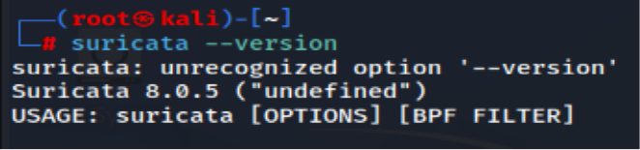
Suricata binary — version confirmation

$ Identifying the Capture Interface
Before touching the configuration file, the correct network interface had to be identified. Running ip a inside the Kali VM surfaced the interface carrying the Host-Only IP (192.168.56.102). This step matters because getting it wrong is silent: Suricata starts cleanly, reports no errors, and simply sees no traffic — there is no error message pointing back to a bad interface name, only an empty alert log.

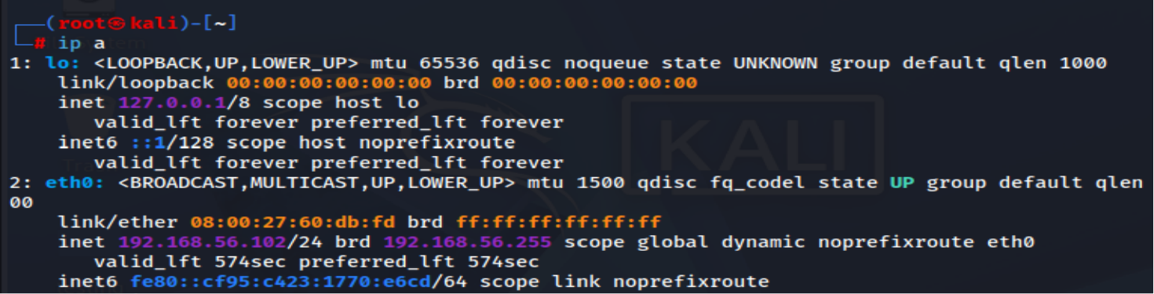
Interface identification on Kali (192.168.56.102)

// 03 DAY 16 — CONFIGURATION & VALIDATION

$ af-packet Configuration
suricata.yaml was edited to point the af-packet capture section — the mechanism that hooks into the Linux kernel's high-performance packet capture path — at the interface identified in Day 15. This is the single setting that determines whether Suricata actually observes traffic.
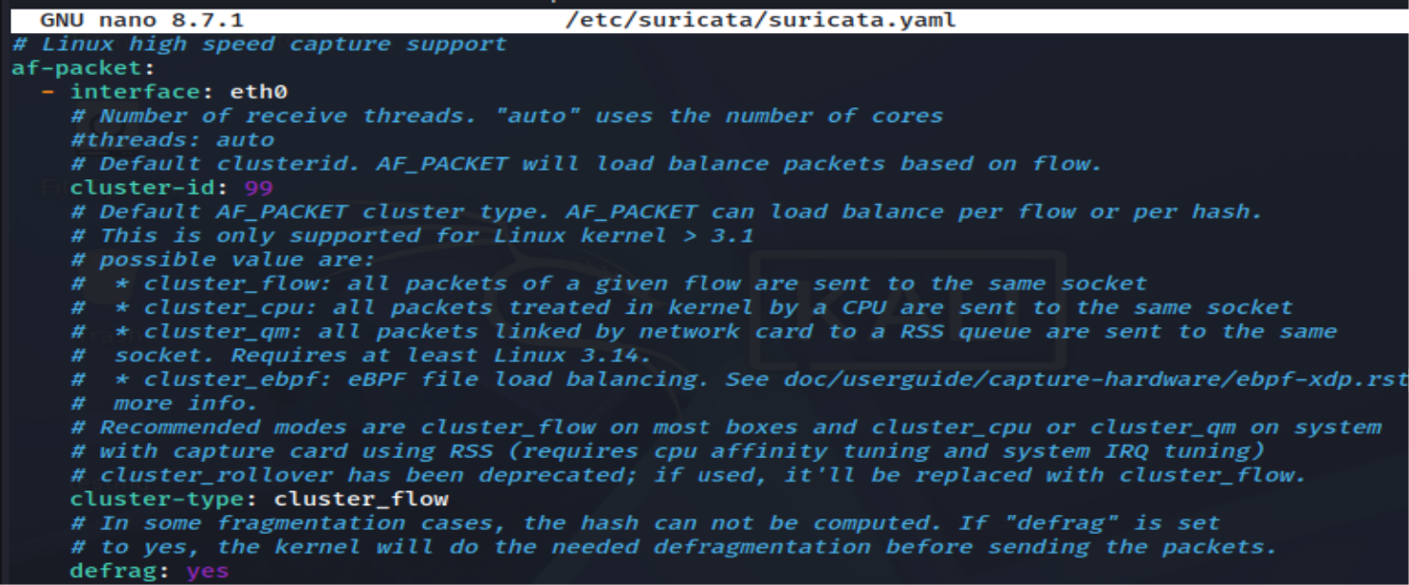
suricata.yaml — af-packet interface binding

$ Service Start & Status
The Suricata service was started and enabled for boot persistence, then checked for an active/running state.
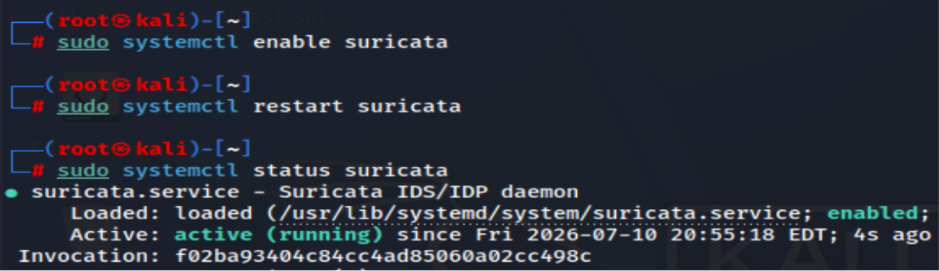
Suricata service status

$ Validation — fast.log
An active service does not by itself confirm the interface is correct — that can only be confirmed by generating traffic and checking whether alerts land in the log. Test traffic (ping, curl, an nmap scan against the Wazuh Manager) was generated from Kali, then fast.log was tailed for alert entries triggered by the default ruleset.
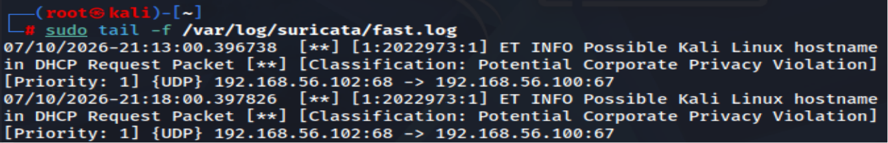
fast.log — signature-based alerts, source/destination IP and port detail

$ eve.json
eve.json was also reviewed as the full structured log — every event Suricata generates, not just alerts: flow records, DNS queries, HTTP metadata, TLS certificate details, and full alert context in JSON. This is the file Wazuh will ingest on Days 18-19 to correlate network alerts alongside host-based detections, so understanding its structure now sets up that integration.
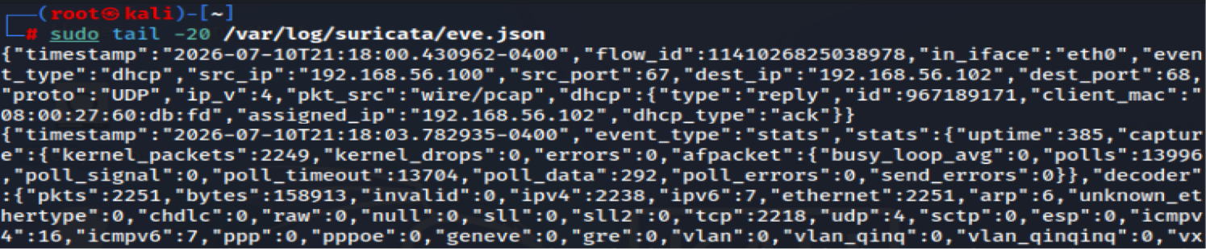
eve.json — full event detail, pending Wazuh integration on Days 18-19

$ Findings
- Suricata installed and version-confirmed on Kali (192.168.56.102).
- af-packet bound to the correct Host-Only interface — confirmed via non-empty fast.log after test traffic.
- Service enabled for boot persistence; systemctl reports active (running).
- fast.log and eve.json both populating — fast.log for quick triage, eve.json staged for the Wazuh ingestion pipeline in Days 18-19.

